Question 1:

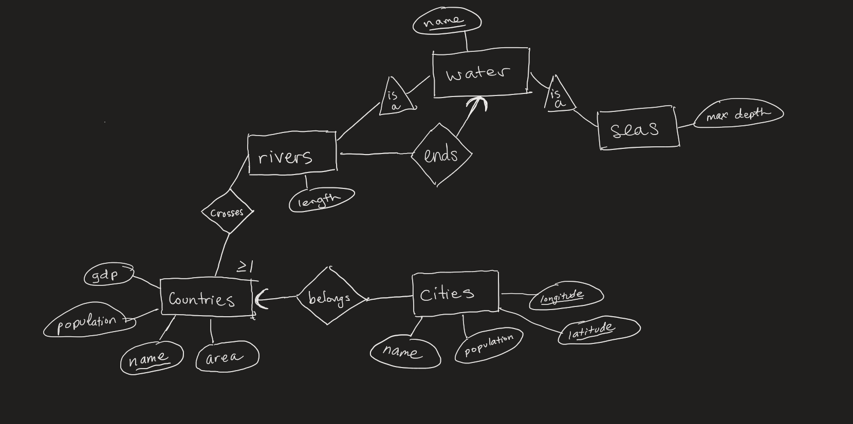

Question 2:

CREATE TABLE InsuranceCo (

name varchar(256) PRIMARY KEY,

phone int

);

CREATE TABLE Vehicle (

licensePlate varchar(10) PRIMARY KEY,

year int,

name varchar(256) FOREIGN KEY references InsuranceCo,

ssn int FOREIGN KEY references Person,

maxLiability real

);

CREATE TABLE Truck (

licensePlate varchar(10) PRIMARY KEY,

ssn int FOREIGN KEY references ProfessionalDriver,

capacity int,

FOREIGN KEY(licensePlate) references Vehicle

);

CREATE TABLE Car (

licensePlate varchar(10) PRIMARY KEY,

make varchar(256),

FOREIGN KEY(licensePlate) references Vehicle

);

CREATE TABLE Person (

ssn int PRIMARY KEY,

name varchar(256)

);

CREATE TABLE Driver (

ssn int PRIMARY KEY,

driverID int,

FOREIGN KEY(ssn) references Person

);

CREATE TABLE NonProfessionalDriver (

ssn int PRIMARY KEY,

FOREIGN KEY(ssn) references Driver

);

CREATE TABLE ProfessionalDriver (

ssn int PRIMARY KEY,

medicalHistory varchar(256),

FOREIGN KEY(ssn) references Driver

);

CREATE TABLE Drives (

ssn int FOREIGN KEY references NonProfessionalDriver,

licensePlate FOREIGN KEY references Car,

PRIMARY KEY(ssn, licensePlate)

)

Question 2b:

For the relationship “insures”, the attributes maxLiability and name in the Vehicle relation represents the relationship in the E/R diagram because for each vehicle, there can only one insurance information corresponding to it.

Question 2c:

The relationship “drives” and “operates” are different as for each truck, there can only be one driver/person operating it, but for car being driven, there can be multiple drivers for each car. This is why they are represented using different tables as one is for trucks and a designated driver for the truck, and multiple drivers for each car.

Question 3:

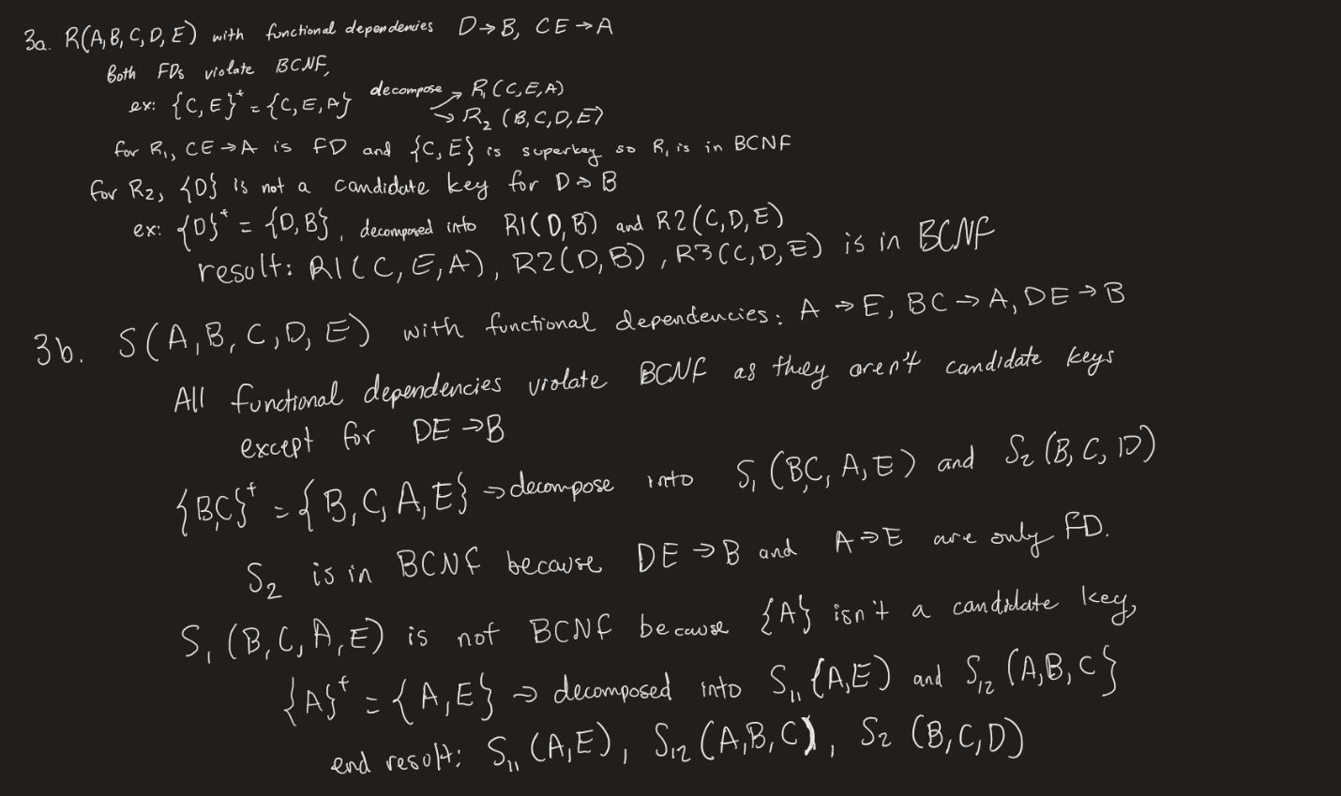

Question 4:

